**Practical 3**

**Aim: Character Counting Application using Python and MapReduce**

**Steps:**

1. File -> New -> Java Project -> Name: CharacterCount

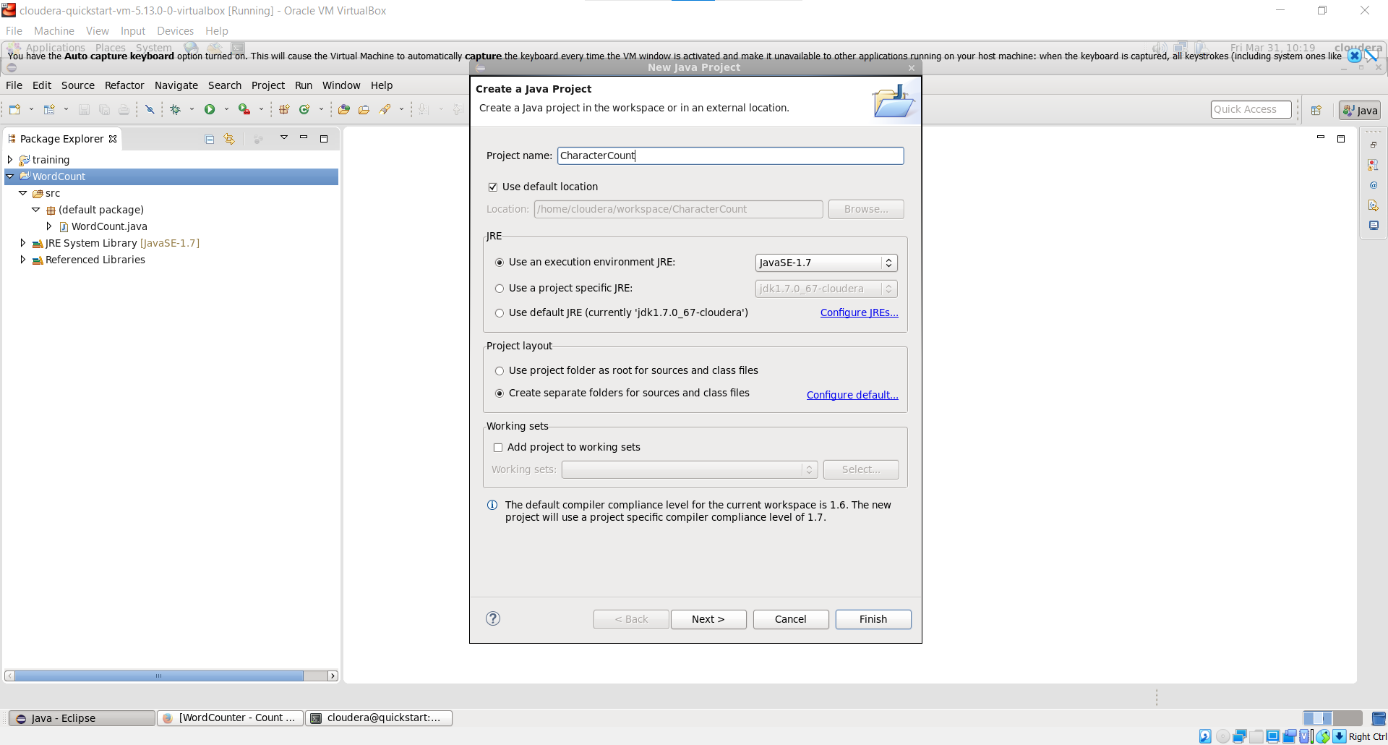

1. Add Hadoop Libraries to the Project

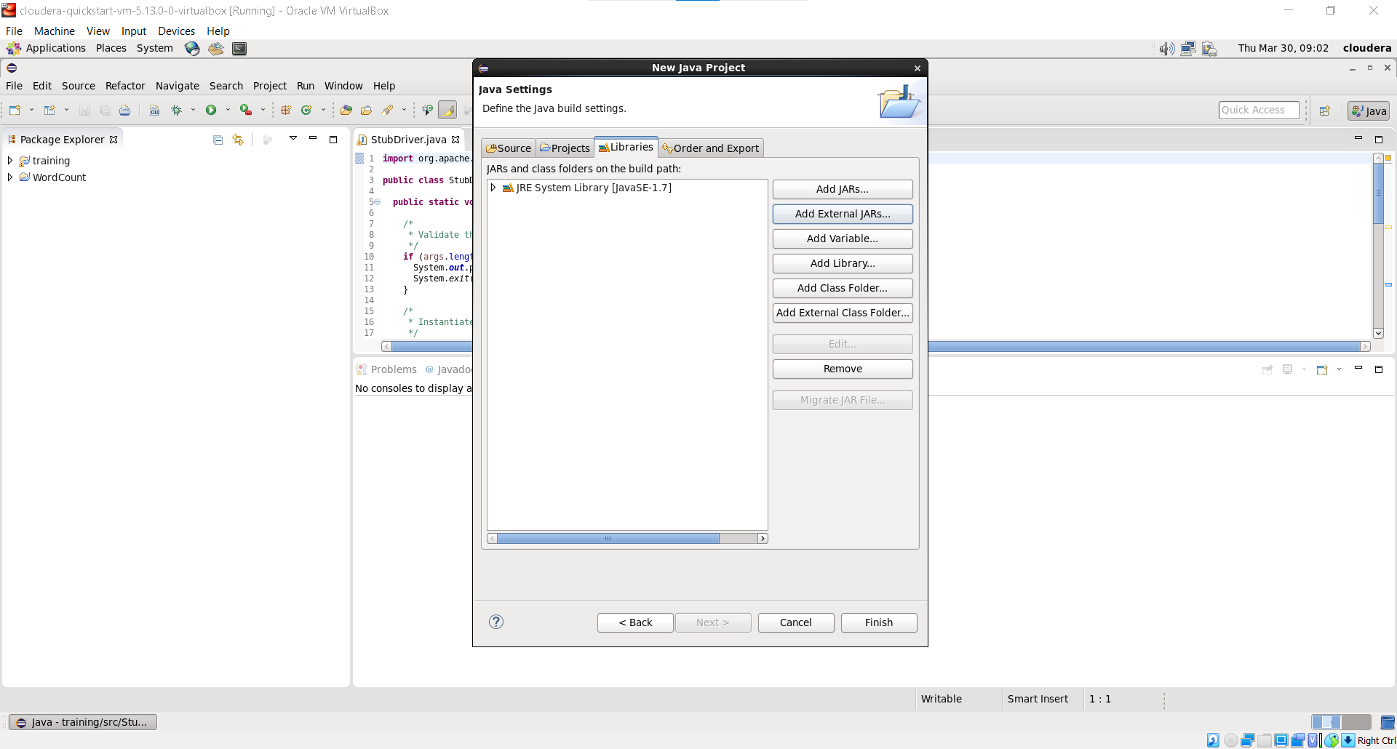

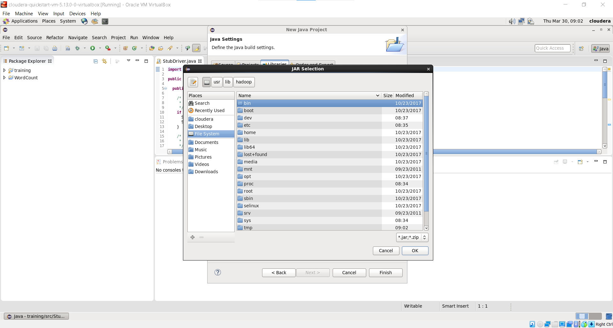

1. JAR Files -> usr/lib/hadoop/

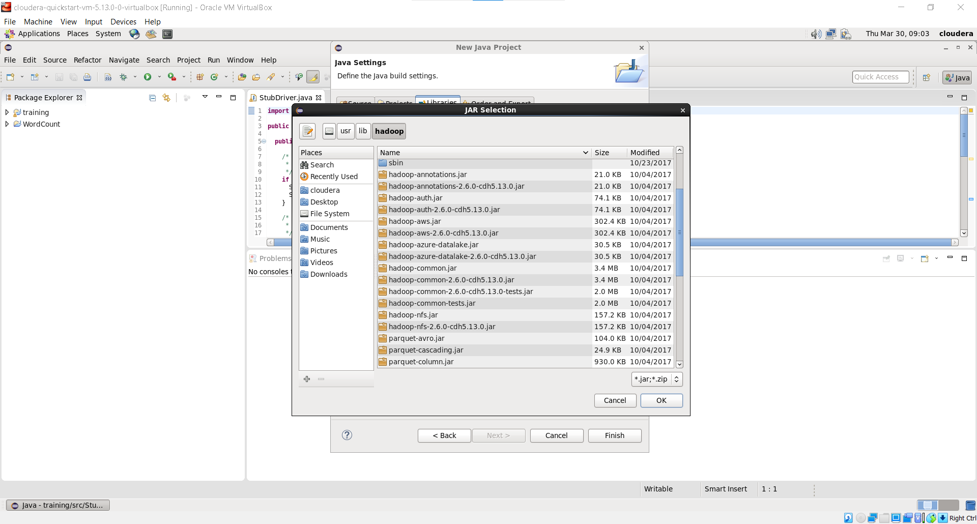

1. JAR File -> usr/lib/hadoop/client

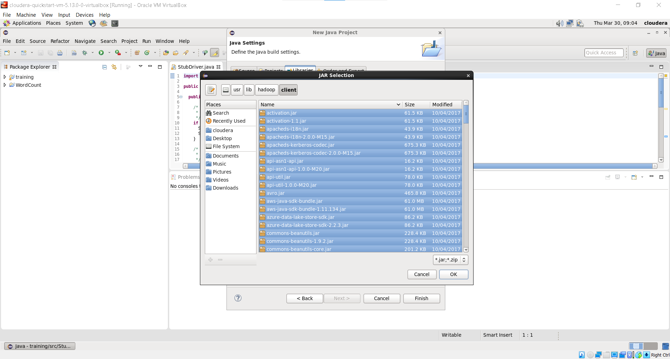

1. Added All Jar Files

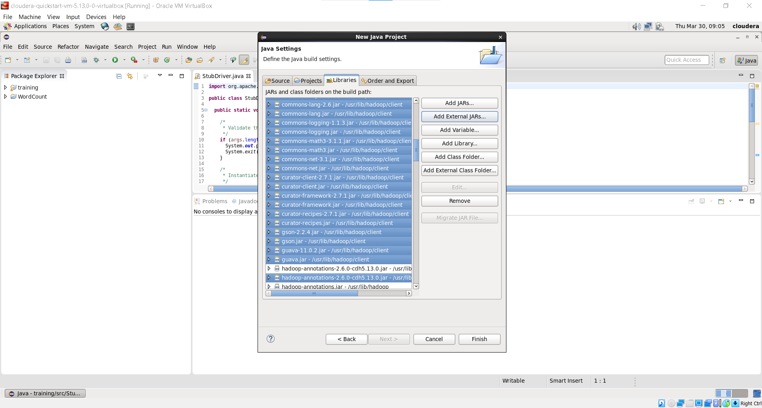

1. Create Classes: Right Click on Project -> New -> Class
   1. CharCountDriver (Main Function)
   2. CharCountMapper
   3. CharCountReducer

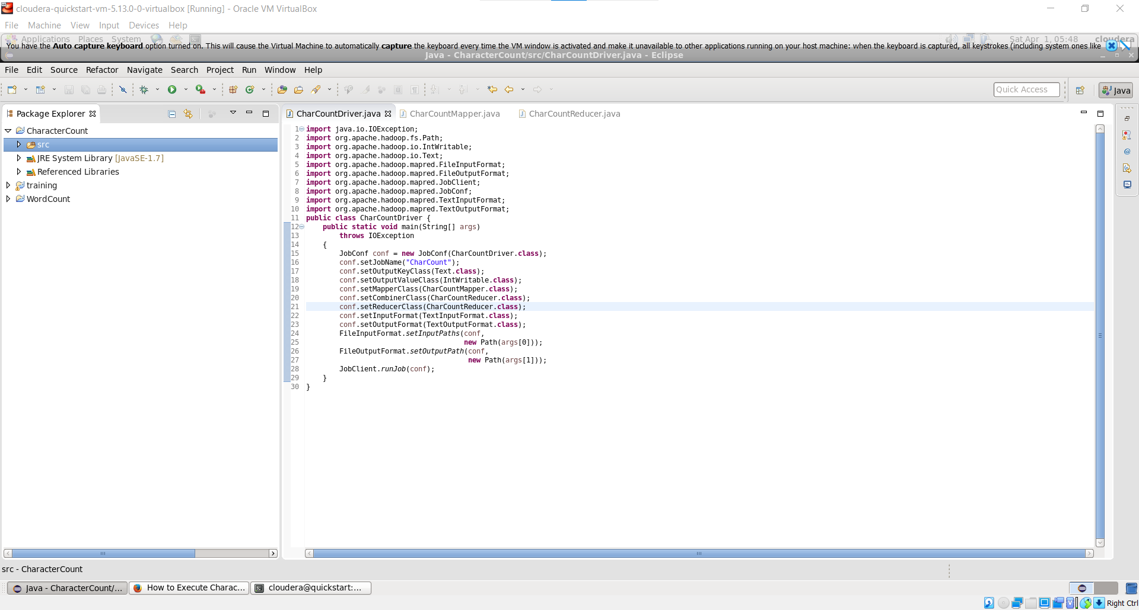

1. Right Click on Project -> Export -> JAR File -> Next (Export destination for JAR file)

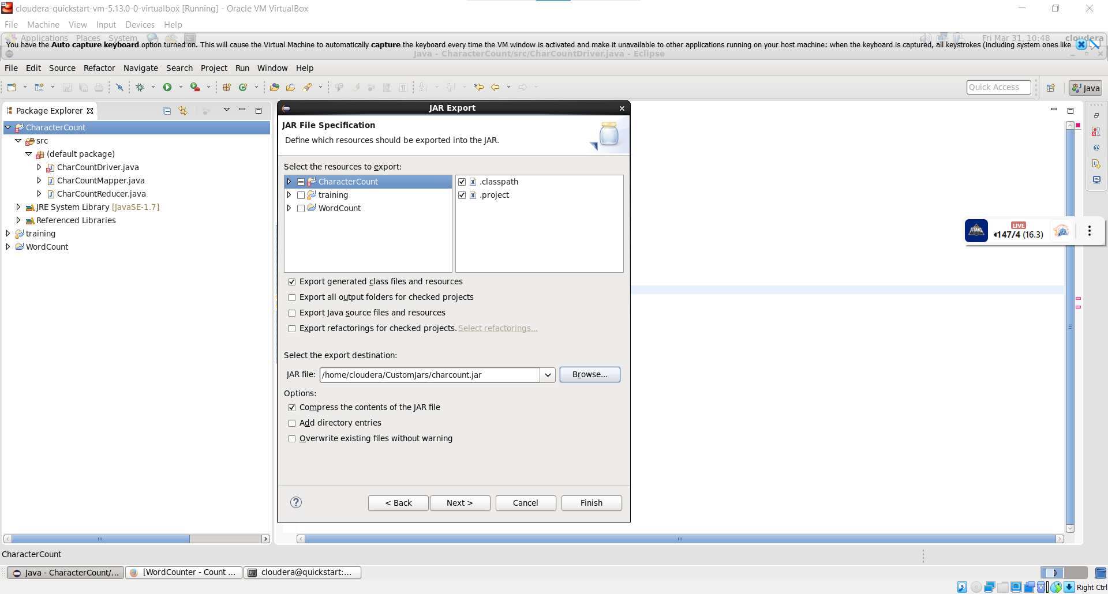

1. Write following commands in terminal

* cd Desktop
* cd dsai
* ls
* pwd
* gedit char_count.txt
* cat char_count.txt
* hdfs dfs -ls /
* hdfs dfs -put char_count.txt /char_inputdir/
* hdfs dfs -ls /char_inputdir
* hdfs dfs -cat /char_inputdir/char_count.txt
* hadoop jar charcount.jar /char_inputdir/char_count.txt /char_outputdir

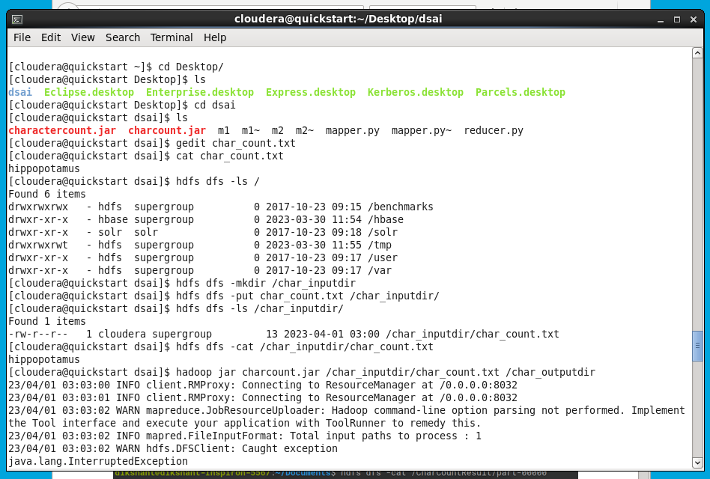

* hdfs dfs -ls /
* hdfs dfs -ls /char_outputdir
* hdfs dfs -cat /char_outputdir/part-00000

